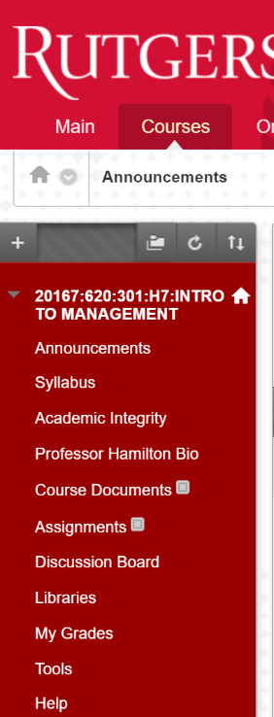**Instructions for Registering a New Clicker**

**Create a TurningPoint Cloud Account**

1. Log into Blackboard using **NetID**
2. Go to any course in your list (Using Introduction to Management as an example here)
3. Click **Tools**

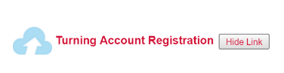

1. Find **Turning Account Registration**
2. Clicker **Turning Account Registration**
3. 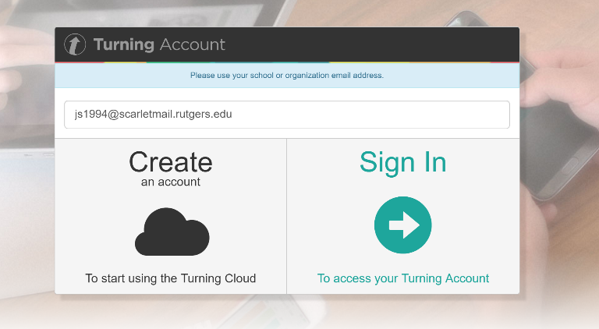Create a TurningPoint Cloud Account using **Scarlet mail**

(e.g. [js1994@scarletmail.rutgers.edu](mailto:js1994@scarletmail.rutgers.edu))

1. Check your Rutgers Email and click verification link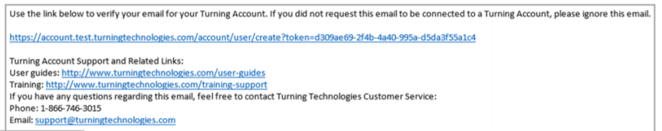
2. Enter all required fields as noted by the asterisks and click **Finish**

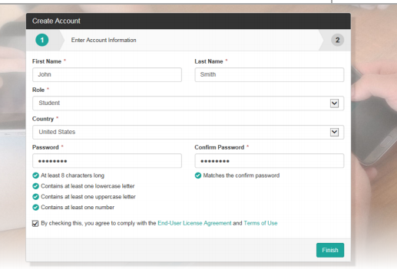

1. Enter a **License Code** and **Device ID** (on the back of your clicker) in the appropriate box and clicker **Redeem** and **Register**

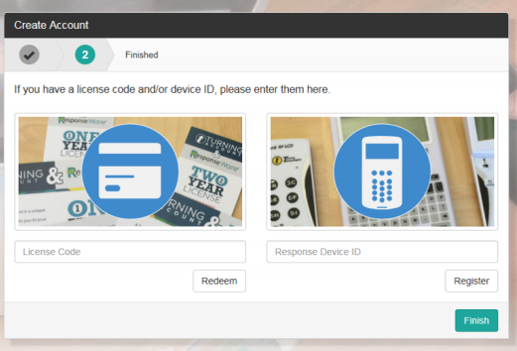

(**Important:** You **must** have a license to participate and receive credit for your responses)

1. The Turning Account Dashboard is displayed. If you have a check mark for **License**, **Device** and **Learning Management System** as showed below, then you are finished. 